TITLE OF PAPER IN ENGLISH

First Author¹, Second Author², Third Author³
¹First Institution (Company), Country Name; ²Second Institution (Company), Country Name; ³Third Institution (Company), Country Name

Abstract: This document gives formatting instructions for authors preparing papers for publication in the Proceedings of the CIBEK22 conference. The authors must follow the instructions given in the document in order for the papers to be published. You can use this document as both an instruction set and as a template into which you can type your own text. Leave two blank lines after the institutional affiliation list. The abstract should contain a summary of the paper in 150 to 300 words. It should be typed using single spaced paragraph without indentation and Times New Roman 12 font.

Keywords: Include at least 5 keywords or phrases

1. INTRODUCTION

This document is a template. An electronic copy can be downloaded from the conference website [1]. For questions on paper guidelines, please contact the conference organization committee as indicated on the conference website. Full papers should be submitted in English language [2-4]. The paper should contain title, list of authors, institutional affiliations, abstract and keywords in both English and Serbian. The manuscripts should be submitted in MS WORD 2003 or in a higher version.
Maximum number of pages is 10, including text, figures, tables, references and appendixes. The paper should be submitted to the organizer in electronic form by e-mail cibek2022@fim-bg.rs

1. 2. PAGE LAYOUT

Paged size of the manuscript should be A4, with a width of 210mm (8.27") and the length of 297mm (11.69"). Margins should be set as follows:

- Top = 30 mm
- Bottom = 25 mm
- Left = 25 mm
- Right = 25 mm

The title of a paper should be typed using uppercase bold letters, Times New Roman 14pt font in continuation (without any line breaks). Below it, in Times New Roman, bold, 12 pt, centred, put the names of authors, their institutions, addresses of institutions including country name, as shown in this document.
All body text should be fully justified. Paragraphs should be single spaced with first line indentation by 1.27cm (0.5”), without any line gaps between consecutive paragraphs. There should not be any styles applied to any of the text in the paper, other than Normal style.
There should not be more than three levels of headings (1. / 1.1. / 1.1.1.). The following headings and subheading format should be used:

1. FIRST LEVEL (Times New Roman, bold, size 12pt, uppercase)
1.1. sECOND LEVEL (Times New Roman, size 12pt, uppercase)
1.1.1. Third level (Times New Roman, bold, size 12pt, sentence case, except for proper nouns or acronyms)

Equations should be centred, in line with text, with the number indicators to the right, as shown:

(1)

Figures should be presented in JPG or TIFF file formats while making sure that they are centred, in line with text and within the margins. Below each figure caption and reference for the figure should be presented. If the figure is the original work of authors, the reference is not required.

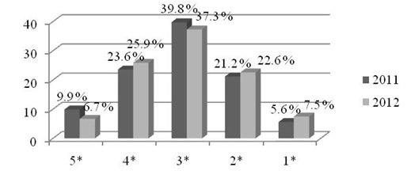
Figure 1. Figure caption [1]

Tables should be within the margins and presented in following way:

Table 1. Table name [2]
Year | Production volume
2012 | 30 000
2013 | 18 000
2014 | 25 000

REFERENCES

Reference list should be at the end of the paper and not presented in the footnotes or endnotes. They should be formatted as follows:

1. Author A., Author B., Serbian Journal of Engineering Management, 33 (1), (2016), 12-24.
2. Author C., The name of the Book, Publisher, City, 2016.
3. Author D., in Handbook (Editor E.), Publisher, City, 2000, 223.
4. Author E., Proceedings of XIII International Symposium of Strategic Management IMCSM17, Date, City, Country, 2017, 123-131.

Reference number should be given in brackets through the text [#] (regular text, not superscript), as shown in the introduction paragraph. References in not-English languages should be translated in English, and original language has to be mentioned in brackets (in Serbian).

